Elijah Andrushenko

CPTS 453

Graph Theory

10-16-2019

Homework 4

1.

Forest of 7 trees G = $\{T_{1},T_{2},T_{3},T_{4},T_{5},T_{6},T_{7}\}$

Each T in the G has 5 vertices, $T_{k}=\{V_{1},V_{2},V_{3},V_{4},V_{5}\}$

There are no cycles in a forest therefore the $dim(C(G)) = 0$

We know that $dim(B(G)) + dim(C(G)) = |E(G)|$

We already know $dim(C(G)) = 0, so dim(B(G)) + 0 = |E(G)|$

Since each T in G is a tree then we know that $|E(T)| = |V(T)| - 1$

$$\left|E\left(G\right)\right|=V\left(T_{1}\right)-1+V\left(T_{2}\right)-1+V\left(T_{3}\right)-1+V\left(T_{4}\right)-1+V\left(T_{5}\right)-1+V\left(T_{6}\right)-1+V\left(T_{7}\right)-1$$

$$\left|E\left(G\right)\right|=|V(G)-7|$$

We already know each tree has 5 vertices so, $V\left(G\right)=5$

$$\left|E\left(G\right)\right|=|5-7|$$

$$\left|E\left(G\right)\right|=2$$

Recall, $dim(B(G)) + 0 = |E(G)|$

Therefore

$$dim(B(G)) + 0 = 2$$

$$dim\left(B\left(G\right)\right)=2$$

2.

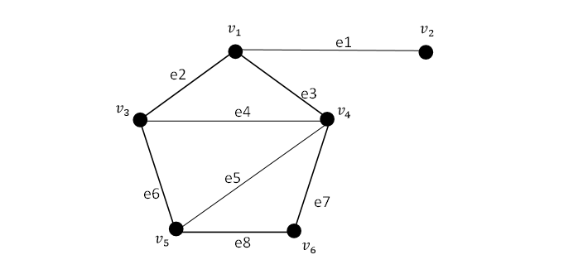

A)

Basis of $B\left(G\right)=\{v_{2}\}$

So $\dim\left(B\left(G\right)\right)=1$

B)

We know that $dim(B(G)) + dim⁡(C\left(G\right)) = |E(G)|$

$$1 +dim⁡(C\left(G\right)) = 6$$

$$dim⁡(C\left(G\right)) = 5$$

Basis of $C(G)=\{v_{1},v_{3},v_{4},v_{5},v_{6}\}$

C)

No nonzero vector exists

3.

4.

$K_{8}$ Has 8 vertices and 28 edges.

We know the equation $n-m+f=0$

The length of each face is $Length\left(f\right)≥3$

Every edge in $K_{8}$ belongs to 2 faces.

Since we know that there are 28 edges then we know $f=28*2=56$

If we plug our numbers back into the equation $n-m+f=0$ we get,

$$8-28+56=0$$

$$-20+56=0$$

$$36=0$$

Which is not true therefore $K_{8}$ cannot be drawn on a torus

5.

A)

$$n - m + f = 2 - 2χ$$

1 face so, f = 1

6 edges so, m = 6

1 distinct vertex so, n = 1

We plug it in and we get

$$1 - 6 + 1 = 2 - 2χ$$

$$-4 = 2 - 2χ$$

$$-6 = - 2χ$$

$$6= 2χ$$

$$χ=3$$

B)

**No**, Nothing changes there is still 1 distinct vertex so the equation wouldn’t change.

6.

Peterson Graph

Number of Edges = 15

Number of Vertices = 10

Number of Faces = 12

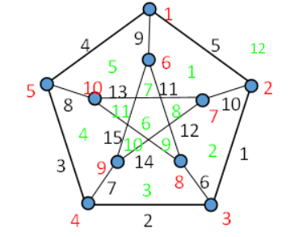

Euler’s Formula for a planar graph is $n+f-e=2$

$$15+12-10≠2$$

Therefore the Peterson graph is not planar.